**SLF ERD**

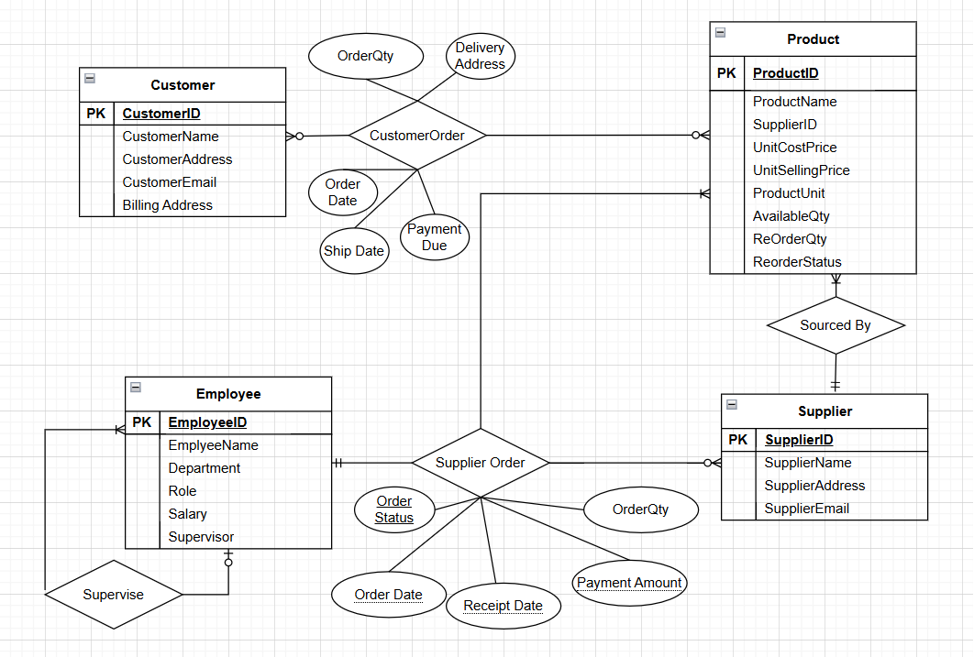

**Assumptions:**

* All SLF employees, other than the Managing Director, are supervised by another employee.
* Each Product will have one and only one Supplier
* When each Product quantity falls below a certain limit (ReOrderQty) - ReOrderStatus will be flagged to ‘Y’ which will trigger a message to the Purchasing Officer. Once a certain number of Products reaches ReOrder status = ‘Y’ the Purchasing Officer can create a SupplierOrder for the relevant Supplier.
* Once a Supplier Order is created – it is in ‘Pending’ status. Once the Supplier Order is received – the Supplier_Order is updated to ‘Complete’ and the Payment_Amount is generated (updated).
* Once the Supplier Order is received – the Order Quantity is automatically added to the Available Quantity in the Product table and the ReOrderStatus is reset to ‘N’.

**SLF Logical Design**

CUSTOMER (CustomerID, CustomerFirstName, CustomerLastName, CustomerAddress,

CustomerEmail, BillingAddress)

PRODUCT (ProductID, ProductName, *SupplierID*, UnitCostPrice, UnitSellingPrice,

ProductUnit, AvailableQty, ReOrderQty, ReOrderStatus)

SUPPLIER (SupplierID, SupplierName, SupplierAddress, SupplierEmail)

EMPLOYEE (EmployeeID, EmployeeFirstName, EmployeeLastName, Department, Role, Salary,

*SupervisorID*)

CUSTORDERHEADER (CustOrderID, *CustomerID*, OrderDate, ShipDate, DeliveryAddress,

PaymentDue)

CUSTORDERDETAIL (CustOrderID, ProductID, Order_Qty)

SUPPLIERORDERHEADER (SupplierOrderID, *SupplierID*, *PurchaseOfficerID*, Order_Date,

Receipt_Date, Order_Status, Payment_Amount)

SUPPLIERORDERDETAIL (SupplierOrderID, ProductID, Order_Qty)

**SLF Physical Design**

CREATE TABLE CUSTOMER (

CustomerID INT PRIMARY KEY,

CustomerFirstName VARCHAR(100) NOT NULL,

CustomerLastName VARCHAR(100) NOT NULL,

CustomerAddress VARCHAR(200) NOT NULL,  
 CustomerEmail VARCHAR(100) NOT NULL,

CustomerBillingAddress VARCHAR(200))

CREATE TABLE SUPPLIER (

SupplierID INT PRIMARY KEY,

SupplierName VARCHAR(200) NOT NULL,

SupplierAddress VARCHAR(300),

SupplierEmail VARCHAR(100) NOT NULL)

CREATE TABLE PRODUCT (

ProductID INT PRIMARY KEY,

ProductName VARCHAR(200) NOT NULL,  
 SupplierID INT NOT NULL,

UnitCostPrice DECIMAL (5, 2) NOT NULL,

UnitSellingPrice DECIMAL (5, 2) NOT NULL,

ProductUnit VARCHAR(20),

AvailableQty INT DEFAULT (0),

ReOrderQty INT DEFAULT (0),

ReOrderStatus VARCHAR(1) DEFAULT ‘N’

CHECK ReOrderStatus IN (‘Y’, ‘N’),

FOREIGN KEY (SupplierID) REFERENCES SUPPLIER (SupplierID) ON DELETE CASCADE)

CREATE TABLE EMPLOYEE (

EmployeeID INT PRIMARY KEY,

EmployeeFirstName VARCHAR(100) NOT NULL,

EmployeeLastName VARCHAR(100) NOT NULL,

Department VARCHAR(50) NOT NULL,

Role VARCHAR(50) NOT NULL,

Salary DECIMAL (10, 2) NOT NULL,

SupervisorID INT,

FOREIGN KEY (SupervisorID) REFERENCES EMPLOYEE (EmployeeID) ON DELETE CASCADE)

CREATE TABLE CUSTORDERHEADER (

CustOrderID INT PRIMARY KEY,

CustomerID INT,

OrderDate DATE NOT NULL,

ShipDate DATE NOT NULL,

DeliveryAddress VARCHAR(200) NOT NULL,

PaymentDue DECIMAL (7, 2) DEFAULT 0,

FOREIGN KEY (CustomerID) REFERENCES CUSTOMER (CustomerID) ON DELETE CASCADE)

CREATE TABLE CUSTORDERDETAIL (

CustOrderID INT,

ProductID INT,

Order_Qty INT NOT NULL,

PRIMARY KEY (CustOrderID, ProductID),

FOREIGN KEY (CustOrderID) REFERENCES CUSTORDERHEADER (CustOrderID) ON DELETE CASCADE,

FOREIGN KEY (ProductID) REFERENCES PRODUCT (ProductID) ON DELETE CASCADE)

CREATE TABLE SUPPLIERORDERHEADER (

SupplierOrderID INT PRIMARY KEY,

SupplierID INT,

PurchaseOfficerID INT,

Order_Date DATE NOT NULL,

Receipt_Date DATE,

Order_Status VARCHAR(10) DEFAULT ‘Pending’ CHECK

Order_Status IN (‘Pending’, ‘Complete’),

Payment_Amount DECIMAL (7, 2) DEFAULT 0,

FOREIGN KEY (SupplierID) REFERENCES SUPPLIER (SupplierID) ON DELETE CASCADE,

FOREIGN KEY (PurchaseOfficerID) REFERENCES EMPLOYEE (EmployeeID) ON

DELETE CASCADE)

CREATE TABLE SUPPLIERORDERDETAIL (

SupplierOrderID INT,

ProductID INT,

Order_Qty INT NOT NULL,

PRIMARY KEY (SupplierOrderID, ProductID),

FOREIGN KEY (SupplierOrderID) REFERENCES SUPPLIERORDERHEADER (SupplierOrderID) ON DELETE CASCADE,

FOREIGN KEY (ProductID) REFERENCES PRODUCT (ProductID) ON DELETE CASCADE)